PORTFOLIO OF EVIDENCE - PART 1
Municipal Services Application
Read Me
Student Number: ST10540538
02 September 2026

GitHub Repository
The full, up-to-date source code for this project is hosted on GitHub at the link below:
https://github.com/PHAKATHWAYO0/MunicipalServicesApp

Project Overview
This is Part 1 of the Municipal Services Application Portfolio of Evidence: a C# .NET Framework (4.8) Windows Forms application that lets citizens report municipal issues (potholes, water leaks, sanitation problems, etc.). The application implements the required "Report Issues" module in full, along with several additional features aimed at making the app more genuinely useful: a live engagement/progress indicator, duplicate-issue detection with a "support this report instead" option, a "My Reported Issues" history screen, and a basic English / isiZulu / Afrikaans language switch.
Per the Task 2 brief, only "Report Issues" is enabled on the Main Menu; "Local Events and Announcements" and "Service Request Status" remain disabled for this submission.

How to Compile and Run
- Requires Visual Studio 2022 (Community edition is fine) with the ".NET desktop development" workload installed.
- Open MunicipalServicesApp.sln by double-clicking it, or via File → Open → Project/Solution in Visual Studio.
- Build the solution: Build → Build Solution, or press Ctrl+Shift+B.
- Run the application: press F5, or click the green ▶ Start button.
- No internet connection or NuGet packages are required — only the built-in System.Windows.Forms libraries are used.

How to Use the Application
- On startup, the Main Menu shows three options; only "Report Issues" is enabled.
- Use the EN / ZU / AF buttons (top-right of the Main Menu) to switch the app's language.
- Click "Report Issues" and fill in Location, Category, Description, and optionally attach a file.
- Watch the progress bar and message update live as each field is completed.
- Click "Submit Report". If a similar issue was already reported nearby, you'll be asked whether to add your support to it instead of creating a duplicate.
- Click "📄 My Reports" at any time to see every issue reported this session, with a live status.
- Every submission is also logged to IssueLog.txt next to the .exe.

Source Code
The images below are syntax-highlighted renders of the actual project source files (not manual screenshots of the Visual Studio IDE), generated directly from the code so the text is fully legible. The complete, unabridged source for every file is included in the accompanying project folder and on the GitHub repository linked above.
Program.cs - Application entry point
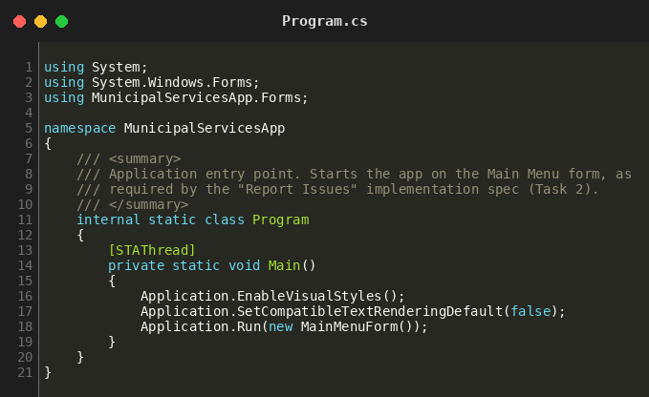
Models/Issue.cs - Data model for a reported issue
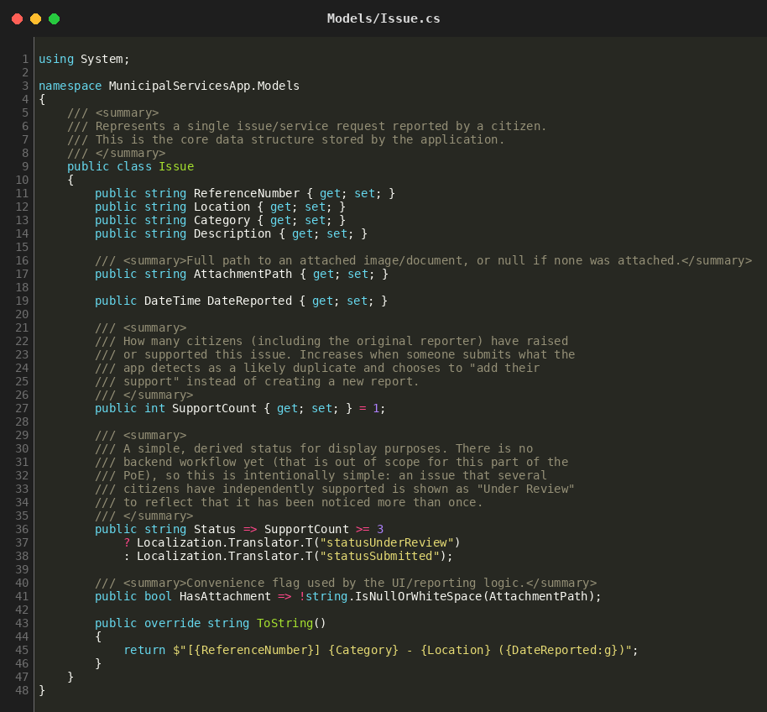
Data/IssueRepository.cs - In-memory store, duplicate detection
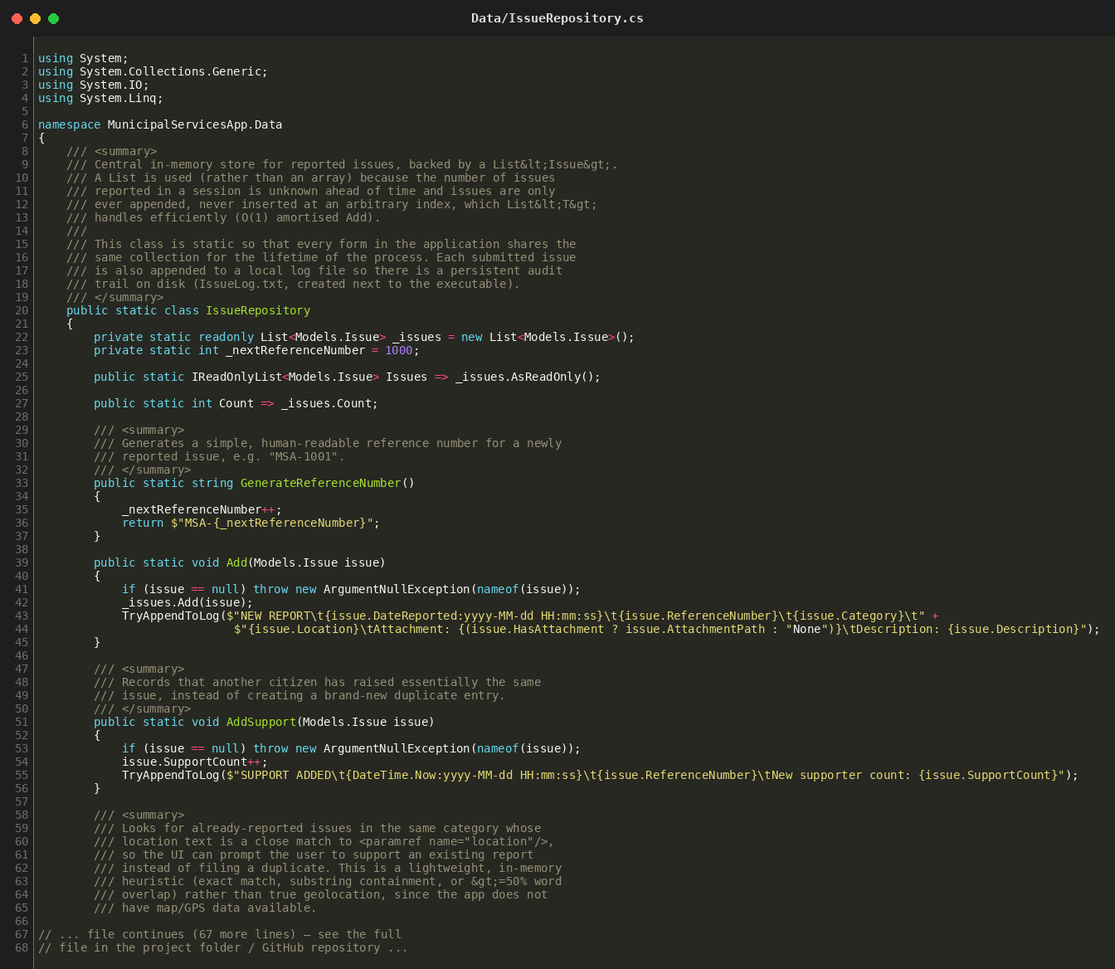
Controls/RoundedButton.cs - Custom rounded/gradient button
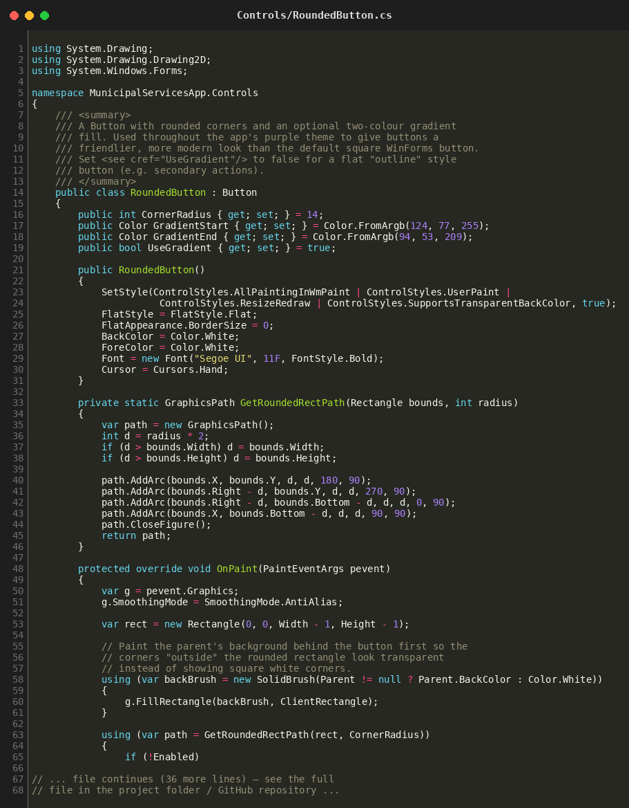
Controls/BlobGradientPanel.cs - Purple gradient hero panel
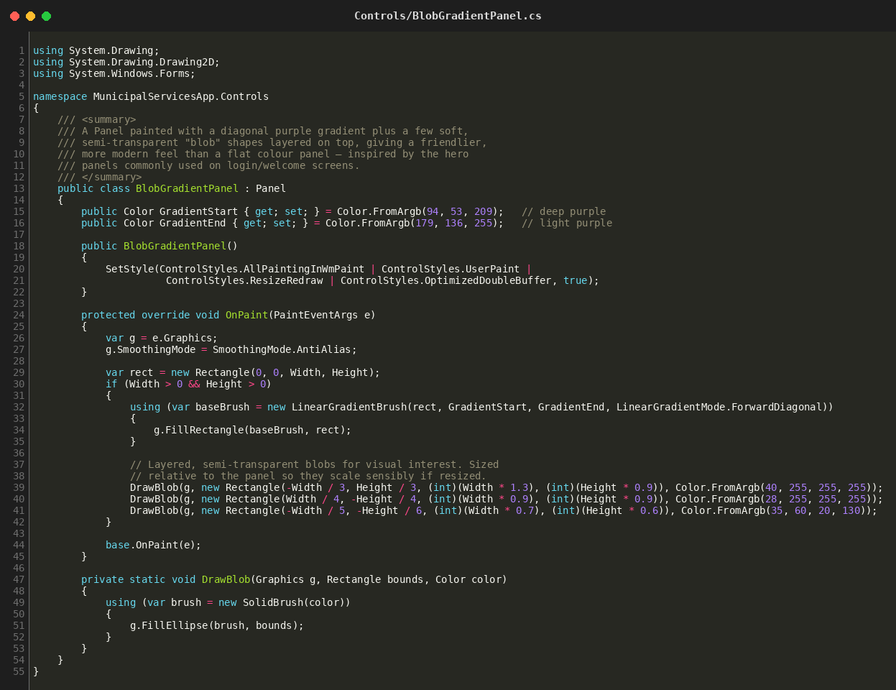
Localization/Translator.cs - EN / isiZulu / Afrikaans text
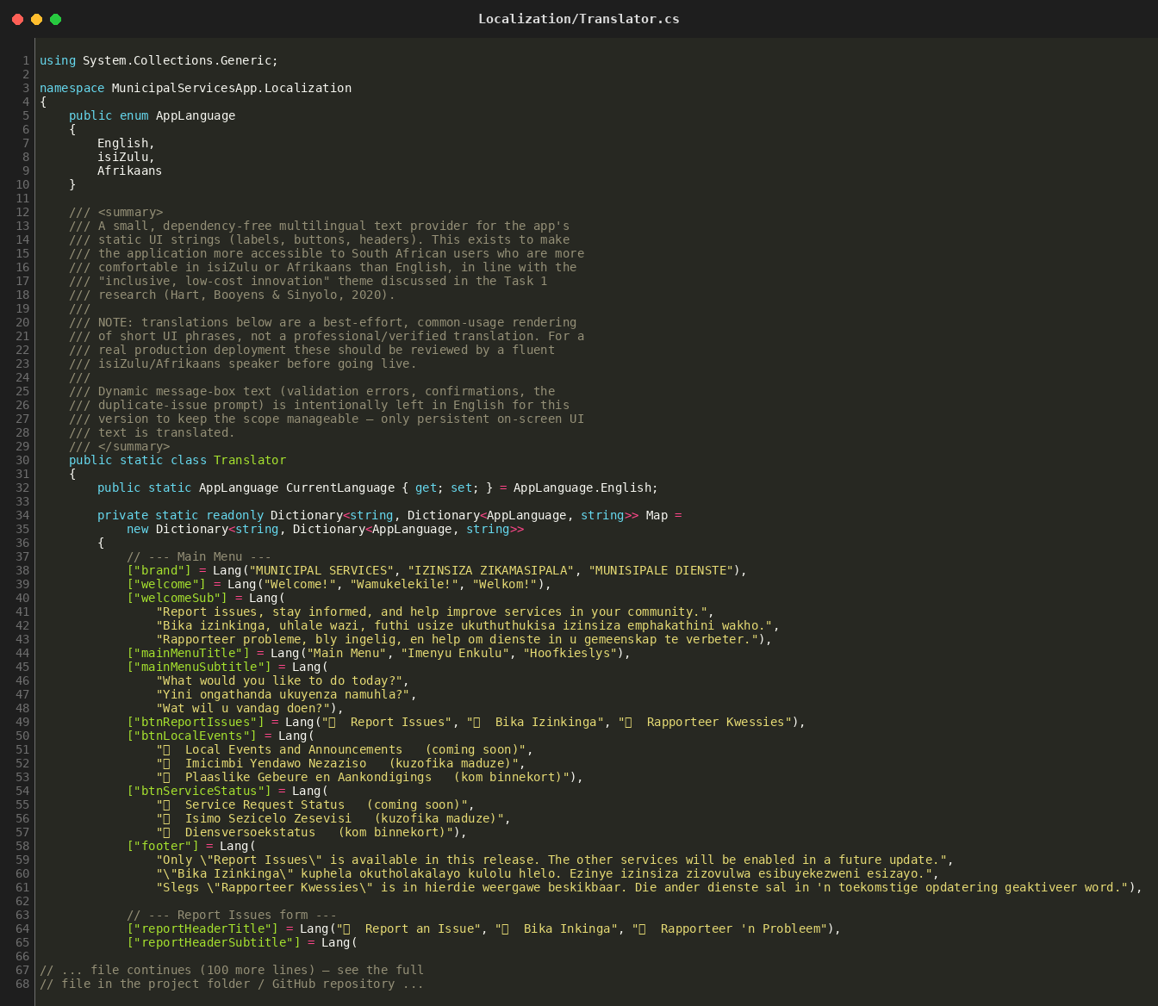

Forms/MainMenuForm.cs - Main menu logic + language switcher
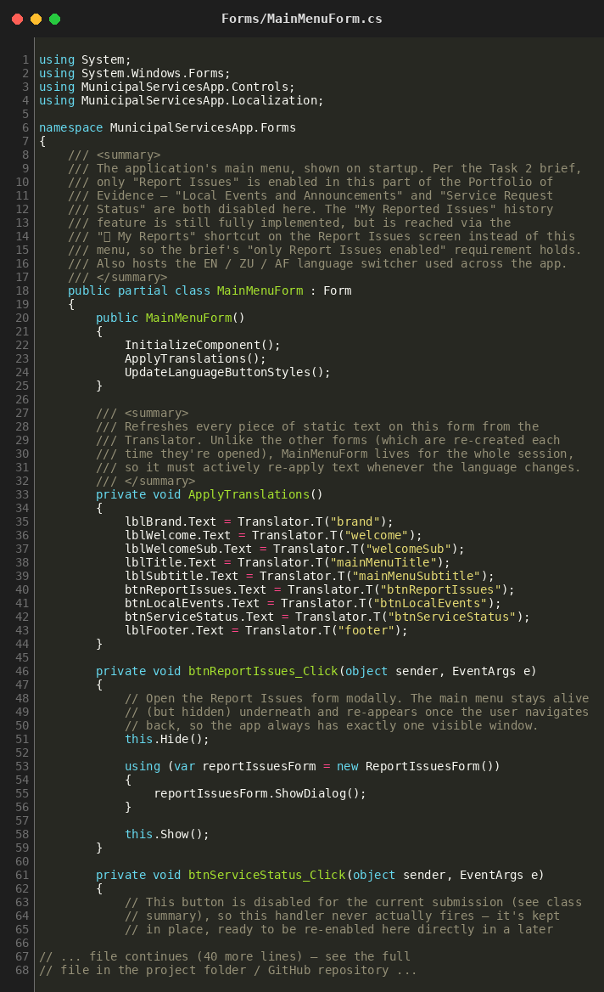
Forms/ReportIssuesForm.cs - Report Issues logic, engagement, duplicate check
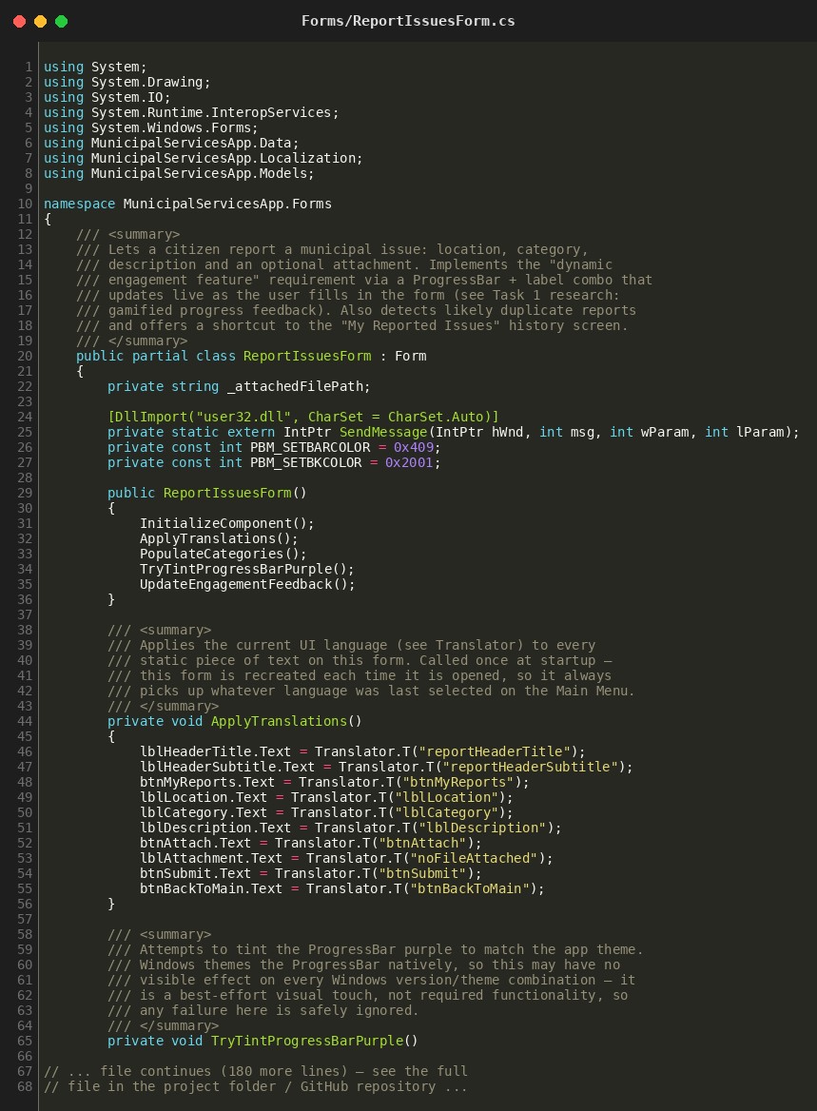
Forms/MyIssuesForm.cs - "My Reported Issues" history screen
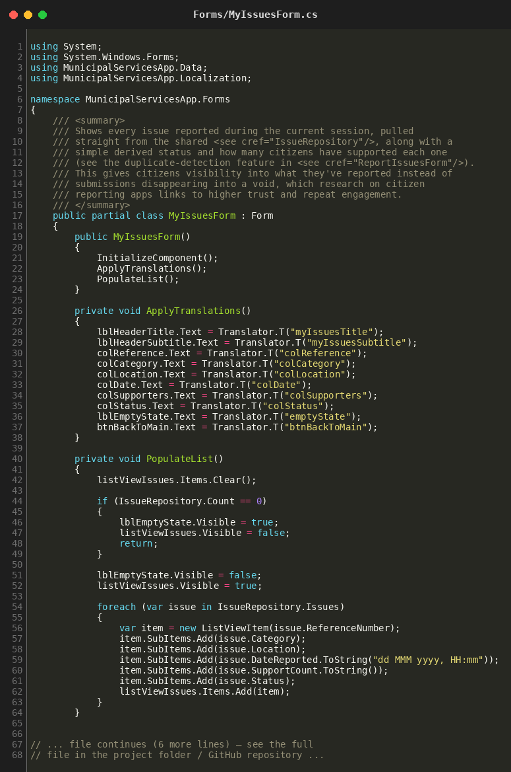

Application Output Screenshots
This section is a template for the running-application screenshots. Please run the application in Visual Studio yourself and paste a screenshot into each box below (click the box, delete the placeholder text, then Insert → Pictures in Word), matching the suggested screens:

